6 Implementation
Design and Implementation of the Algorithms
6.1 Overall Application Structure

Each algorithm is called from a single façade class called XTractor. This enables easy access from the GUI or indeed any external API caller.

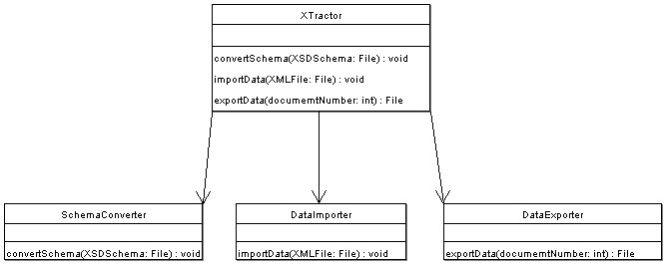
Figure 6.1: The XTractor class is a façade to the algorithms. External applications can access all functionality through this class.

Each algorithm is implemented in a separate package. However, some functionality is required by more than one of the algorithms. Classes providing such functionality are found at the level above any particular algorithm’s package for universal access.

6.1.1 Database interaction

The most significant functionality required by more than one algorithm is that of database interaction. Classes supporting database manipulation are found in the Database Manager family of classes.

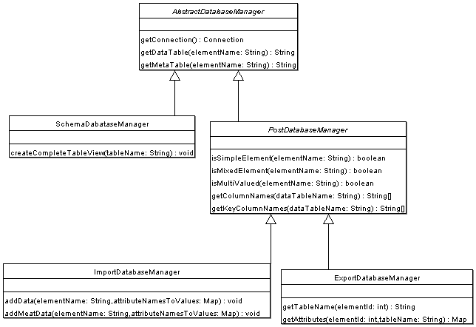
Figure 6.2: The hierarchy of Database Managers, which share much functionality

The hierarchy of database managers reflects the different type of operations possible in each database manager.
- The AbstractDatabaseManager contains methods available to all algorithms. Such methods include translating between XML nomenclature and relational database nomenclature (and vice versa). For example, if any subclass required the meta table corresponding to part, a method in AbstractDatabaseManager would return meta_part. The class is also responsible for handling connecting to the database. Any subclasses only have to call getConnection() to connect to the database.
- SchemaDatabaseManager is available only to the SchemaConverter application. It has methods for creating tables and populating catalog tables.
- PostDatabaseManager can obtain information from the relational database schema or catalog tables, because it is only ever used after the relational schema has been generated (hence the prefix ‘post’). This information is of use in both the DataImporter and DataExporter applications.
- ImportDatabaseManager contains methods for adding information to data and meta tables in the relational database. This class is only available for use by the DataImporter application.
- ExportDatabaseManager contains methods for reading data from the relational database tables. This class is only available for use by the DataExporter application.

The operation of these database managers requires naming conventions to be established. Naming conventions are specified in a class called Naming, which the AbstractDatabaseManager has static access to. This Naming class’ visibility is such that only the database managers can use it. No other classes should be concerned with naming conventions.

6.2 Schema Conversion

The schema conversion process begins by calling the public method in the SchemaConverter class.

Reflecting the two-phase nature of the schema conversion process, XER Model building followed by Relational Database generation, different classes are used by SchemaConverter to handle each stage.

The first class, the XERBuilder, has a method to build an XER Model given an JDOM model of the XML Schema file. The XER Model is returned to SchemaConverter.

The second class, the RDBBuilder, has a method which creates a relational schema based on the XER Model supplied by SchemaConverter.

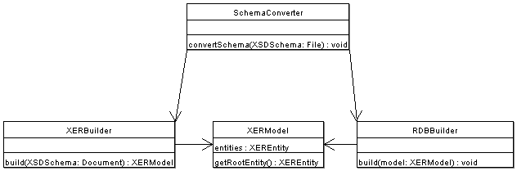
Figure 6.3: The main classes used to implement Schema Conversion

Implementation of the two stages is now described in more detail.
6.2.1 Building the XER Model

The XERBuilder class retrieves constructs in the XML Schema document it was passed by querying an XSDReader class. The XSDReader class uses the XSD Infoset Model.

Once an XML Schema construct has been retrieved with the aid of XSDReader, it is passed to an appropriate XML Schema component parser this will be one of the concrete subclasses of AbstractParser. This has the advantages associated with the ‘delegate strategy’ design pattern, such as ease of extensibility and call transparency.

The appropriate parser examines the construct in detail and decides on an XER construct to create. Creation of XER constructs is delegated to the XERFactory, which contains factory methods. No other class has access to the constructors of the various XER constructs. In addition to creating the constructs, the XERFactory is responsible for adding them to the XERModel object, together with any XER model meta information (e.g. which is the root XER Entity).

There is common content in the various XER constructs. For example, they all have a name of some sort. They can also have an alias. In addition, it must be possible to get and set such information. The partial similarity between constructs makes it appropriate to introduce a hierarchy of XER constructs, shown in figure 6.5.

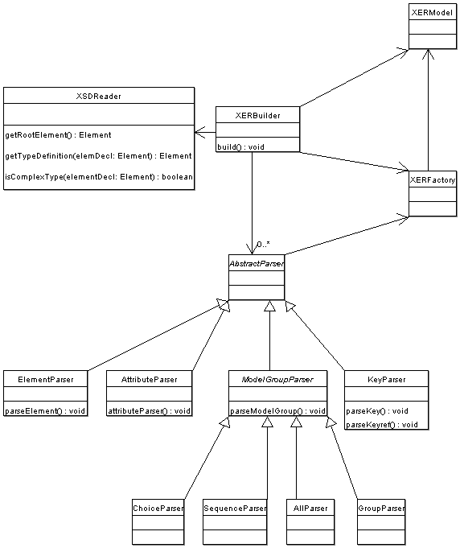
Figure 6.4: The classes used to build an XER Model

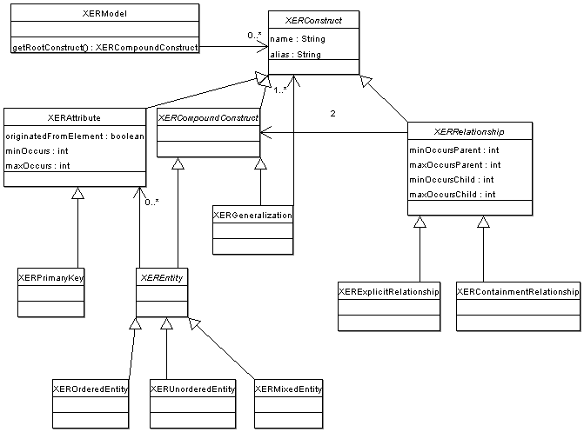
Figure 6.5: The hierarchy of XER constructs

6.2.1.1 Implementation Issues

The XER modelling process described in [6] doesn’t represent some fundamental XML Schema information (such as the data type of an XER attribute, or the maximum length of an attribute’s value). However, it is necessary to retain all relevant information to be able to build the correct relational schema. Therefore, the XER data structures contain much more information that the theoretical XER model’s constructs.

Due to the layout of XML Schema, it is only discovered that some attributes are primary key attributes some time after the attribute’s declaration has been parsed. Therefore, rather than creating XER primary key attributes, it is necessary to promote existing attributes to key attributes.

Later it becomes is necessary to know what XER Relationships originated implicitly from the containment (of a complex element within a complex element) as opposed to keyref constructs in an XML Schema. We therefore distinguish between containment relationships and explicit relationships by using different subclasses of XERRelationship.
6.2.2 Creating the Relational Schema

The RDBBuilder walks over the XERModel it was passed. For each construct it encounters, it invokes an appropriate XER construct parser. This parser, a concrete subclass of XERAbstractParser, decides what relational database constructs to create and returns a string of SQL code which does this. This includes code to add to the catalog tables.

The string of SQL code is written to a file.

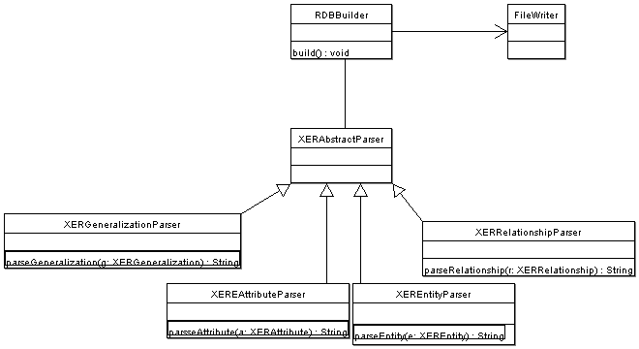
Figure 6.6: The main classes required to build a relational schema

When all XER constructs have been parsed and the appropriate code has been written to the script, the script is invoked.

The relational schema has then been realized.

6.2.2.1 Implementation Issues

The system administrator at this particular institution has disabled creation of databases. To allocate an exclusive space for each relational schema created, it is necessary to use Tablespaces. In PostgreSQL, these are called ‘Schemas’.

Previously it was stated that the entities had to be parsed in the right order so that the corresponding table creation code didn’t suffer from referential integrity problems. It was also stated that the order be enforced by postponing the parsing of entities referencing unparsed entities. This has been implemented by throwing an EntityNotParsedException whenever attempting to parse an XER Entity that has a relationship with another entity that has not yet been parsed. The RDBBuilder catches this exception and moves on to the next iteration without writing any table creation code for the prematurely considered entity. As this entity is not added to the parsed entities list, it is reconsidered during a second pass through the set of entities.

Deciding on mappings between XML Schema and SQL datatypes is never likely to be optimal. Indeed, it is often a matter of user preference. For this reason, an XML configuration file called typeMappings.xml is read to determine the mappings. This can be easily changed by the user.

6.3 Data Importing

The data importing process begins by calling the public method in the DataImporter class, and passing the XML data file as a parameter. A JDOM Document model of the file is build and passed to the XMLWalker, which has to decide on an order to walk over the document. It uses a Dependency Graph.

The Dependency Graph is built by the DependencyGraphBuilder. This requires access to the database to read the database meta data. The graph is built using the JGraphT API. Crucially, this API supports deletion of nodes from a graph and its edges, making the algorithm simpler to implement. The graph returned is of type DirectedGraph, a class in the JGraphT API.

Once the XMLWalker knows in what order to iterate through the document’s elements, it does so and instructs a DataPopulator class to examine each element.

The DataPopulator extracts the relevant features of the XML element (through the JDOM API) and packs them into an attribute map (a Map from attribute names to attribute values) and invokes the addData() and addMetaData() methods in the ImportDatabaseManager. It is not the DataPopulator’s responsibility to translate the XML nomenclature into relational database nomenclature. As stated before, this is the sole responsibility of the database managers.

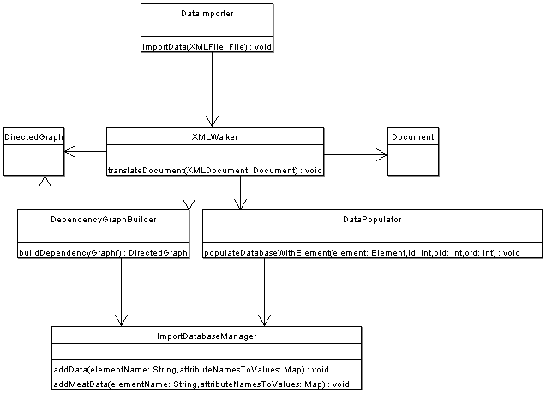
Figure 6.7: The main classes in the implementation of the Data Importing algorithm

6.3.1 Implementation Issues

A common problem with adding data to a database is that it is not possible at compile time to determine whether to perform an SQL INSERT or UPDATE, yet the ImportDatabaseManager needs to be able to do both in the right context. This is dealt with by making use of Exceptions: the database manager initially attempts to insert the data into a new row in the database. If this fails, the SQLException is caught. If the cause of the exception is that a duplicate primary row exists, then an update is then attempted. This has the effect of updating the existing row containing that particular primary key. One problem with performing an UPDATE is that the method responsible for formulating the command must know which columns are key columns and which are not. This is because the syntax is of the form:

UPDATE tableName
SET nonKeyColumnName = nonKeyColumnValue
WHERE keyColumnName = keyColumnValue

Such distinctions are not necessary for INSERT commands. The solution is to determine the key columns from the table’s meta data. While this is not complex to implement, it incurs a performance penalty from the extra database round trip.
6.4 Data Exporting

To reconstruct XML documents, the public method in the DataExporter is called with the number of the relevant document. Implementing the operation requires less classes that the previous two.

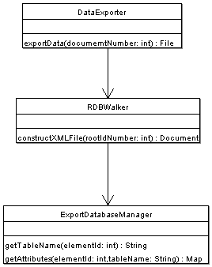
Figure 6.8: The main classes implementing document reconstruction

The RDBWalker is responsible for requesting the relevant information to reconstruct each XML element as well as inserting the elements into the correct location in the JDOM document it has generated.

The information the RDBWalker requests is retrieved from the database via the ExportDatabaseManager.
6.5 Graphical User Interface

The GUIController class is responsible for invoking the relevant algorithm when the user instructs to do so via the Graphical User Interface. The GUIController is constructed and invoked by the Application class, which contains the application’s main method.

A separate frame controller is allocated to each frame that exists in the application. Each frame controller is a concrete subclass of the AbstractFrameController. These controllers are responsible for constructing their corresponding frames and handling any events, usually by referring them to the main GUIController. All calls to the XTractor API are done via such a call chain.

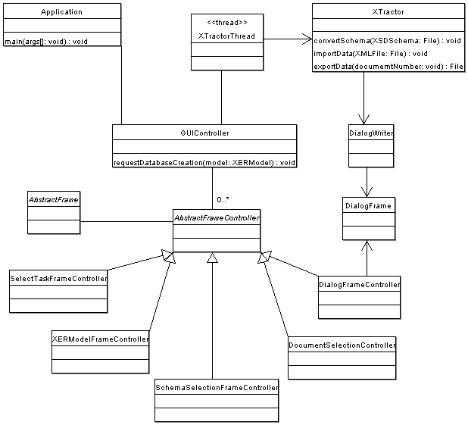
Figure 6.9: The main classes to construct and interact with a GUI, as well as invoke the algorithms

However, if the XTractor methods were called directly then the GUI would freeze until the call is complete. This may be acceptable in some situations such as when constructing the XER model, which has a relatively short duration. But in other cases the graphical interface must be simultaneously active, not just because the API call takes longer to complete (due to the database interaction) but because the user must be informed of the progress of the algorithm at the earliest possible time. It is not acceptable to be informed of the result of an algorithm operation when the whole algorithm has terminated.

For these reasons, it in necessary to access the XTractor API via a separate thread, called XTractorThread. The GUIController requests the XTractorThread to make an API call to XTractor and the GUIController immediately gets control back. In parallel, the XTractorThread services the request.

In fact, when a user wishes to create a relational schema based on an XML Schema, the two stages are explicitly separated. In other words, the user is initially returned a visual representation of the XER Model. Changes to the model can be made via this visualization. Only after the user has modified the model to their personal taste does the relational schema generation algorithm proceed, taking account of these modifications.

When any of the 3 algorithms are invoked, the XTractor classes need to know where to direct dialog output. Therefore a DialogWriter object is passed.

In addition to making calls to invoke the 3 algorithms, the XTractor API needs to support other operations. These include retrieving a list of relational schemas that have been generated and documents that have been imported into a particular relational schema.

6.6 Testing

The XTractor application has been tested with the parts and suppliers XML schema, producing the relational schema shown in figure 6.10.

List of relations
Name
Typecatalog_attributes | table
catalog_elements | table
catalog_specializations | table
catalog_ids_to_tables | view
complete_name | view
complete_part | view
complete_ps_db | view
complete_supplier | view
complete_supplies | view
meta_name | table
meta_part | table
meta_ps_db | table
meta_supplier | table
meta_supplies | table
name | table
name_choice | table
part | table
ps_db | table
ps_db_choice | table
supplier | table
supplies | table
Figure 6.10: All tables and views produced by the Schema Converter

After insertion of data from a first document, the tables were contained the data shown in figure 6.11.

ps_db
  ps_db_pkey
  1
  ps_db_choice
  ps_db_pkey | pno | sno
  1 |  | 20I
  1 |  | 50J
  1 |  | 63H
  1 | 100
  1 | 101
  1 | 102
  supplier
  sno | town
  20I | London
  50J | Oslo
  63H | Paris
  part
  pno | colour | price
  100 | red | 20
  101 | red | 22
  102 | yellow | 11
  name
  name_pkey | name | sno
  1 | I electronics | 20I
  2 | J & S | 50J
  3 | <HTML> SA | 63H
  name_choice
  sup | name_pkey
  supplies
  sno | supplies
  20I | 100
  20I | 102
  50J | 100
  50J | 101
Figure 6.11: The contents of the data tables after importing the parts and suppliers XML document

The regenerated version of the document was is shown in figure 6.12.

<ps_db>
<part colour="red" price="20.0" pno="100" />
<part colour="red" price="22.0" pno="101" />
<part colour="yellow" price="11.0" pno="102" />
<supplier sno="20I" town="London">
<name>I electronics</name>
<supplies>100</supplies>
<supplies>102</supplies>
</supplier>
<supplier sno="50J" town="Oslo">
<name>J & S</name>
<supplies>100</supplies>
<supplies>101</supplies>
</supplier>
<supplier sno="63H" town="Paris">
<name><HTML> SA</name>
</supplier>
</ps_db>
Figure 6.12: The regenerated parts and suppliers XML document

One may notice the absence of the sup element inside the first name element. At the time of writing, handling simple element data that is within a choice had not been fully implemented.

When a second document, shown in figure 6.13, was imported the relational database tables that changed contained the data show in figure 6.14. The supplies table was (correctly) not updated because there is no such part with number 104.

<ps_db>
<part pno="100" colour="red" price="30" />
<part pno="103" colour="green" price="10" />
<supplier sno="50J">
<supplies>104</supplies>
</supplier>
</ps_db>
Figure 6.13: A second XML document that was imported

  ps_db
  ps_db_pkey
  1
  2
  ps_db_choice
  ps_db_pkey | pno | sno
  1 |  | 20I
  1 |  | 50J
  1 |  | 63H
  1 | 100
  1 | 101
  1 | 102
  2 | 103
  supplies
  sno | supplies
  20I | 100
  20I | 102
  50J | 100
  50J | 101
  part
  pno | colour | price
  100 | red | 20
  101 | red | 22
  102 | yellow | 11
  103 | green | 10
Figure 6.14: The contents of relevant data tables after importing the second document

Now when the first document was regenerated, its values reflected the latest information that the second document provided. For example, the part with pno 100 now had a price of 30. This updated regenerated document is shown in figure 6.15.

<ps_db>
<part colour="red" price="30.0" pno="100" />
<part colour="red" price="22.0" pno="101" />
<part colour="yellow" price="11.0" pno="102" />
<supplier sno="20I" town="London">
<name>I electronics</name>
<supplies>100</supplies>
<supplies>102</supplies>
</supplier>
<supplier sno="50J" town="Oslo">
<name>J & S</name>
<supplies>100</supplies>
<supplies>101</supplies>
</supplier>
<supplier sno="63H" town="Paris">
<name><HTML> SA</name>
</supplier>
</ps_db>
Figure 6.15: The regenerated first document, but containing the up-to-date information

The attributes of the part element do not occur in the same order as in the original document: it was pno, colour, price whereas here it is colour, price, pno. Also, extra decimal place zeros had been added by the JDOM document builder for the price attribute values.

The whitespace is not identical to the original document, because this was not stored. Instead, JDOM’s pretty printer was used to format the document.

Other features are being added to the application.

